**Testing actions within QA Android app to see logs on Kibana.**

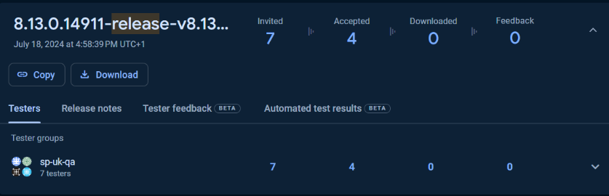

Using Firebase to download the latest Android apk of the SP Mobile App.

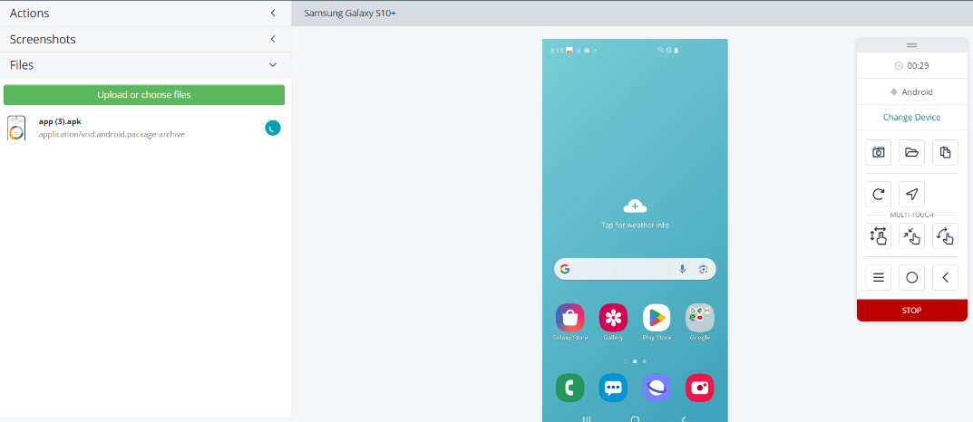Remotely accessing a mobile testing device (Samsung Galaxy 10+) and adding the app apk file so that the SP app is loaded onto device.

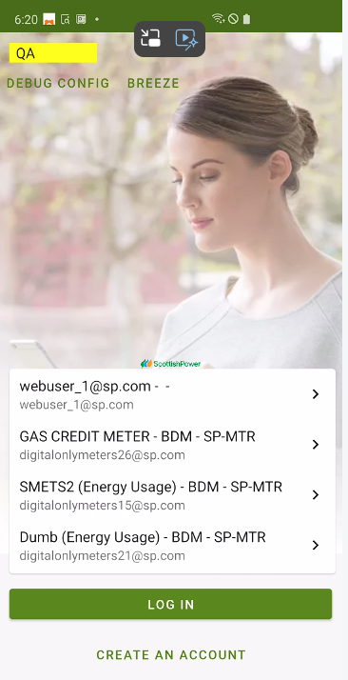

Open app and change the environment to QA and login with the testing account.

Attempted £30 top-up on a gas account.

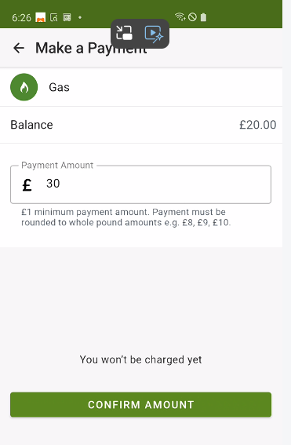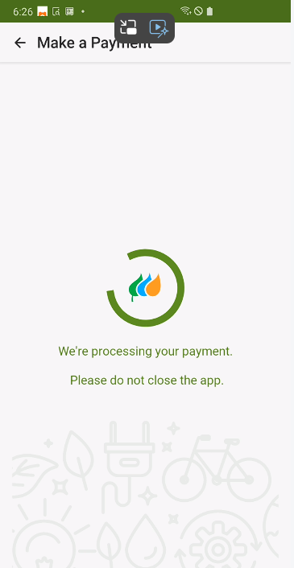Entered test card details and confirmed payment.

Card details accepted so payment is processing.

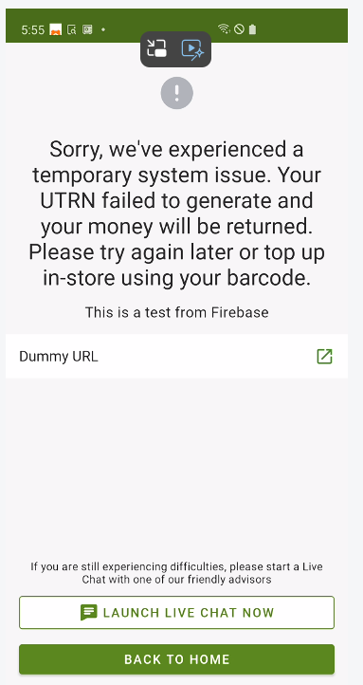

Error occurred so went to check logs for issue.

Log for this would be found in Kibana test version as this was QA.

‘kibana.test-internal-app.scottishpower.co.uk’

Logged in and went to:

Observability/APM/Services/sp-payments/Logs

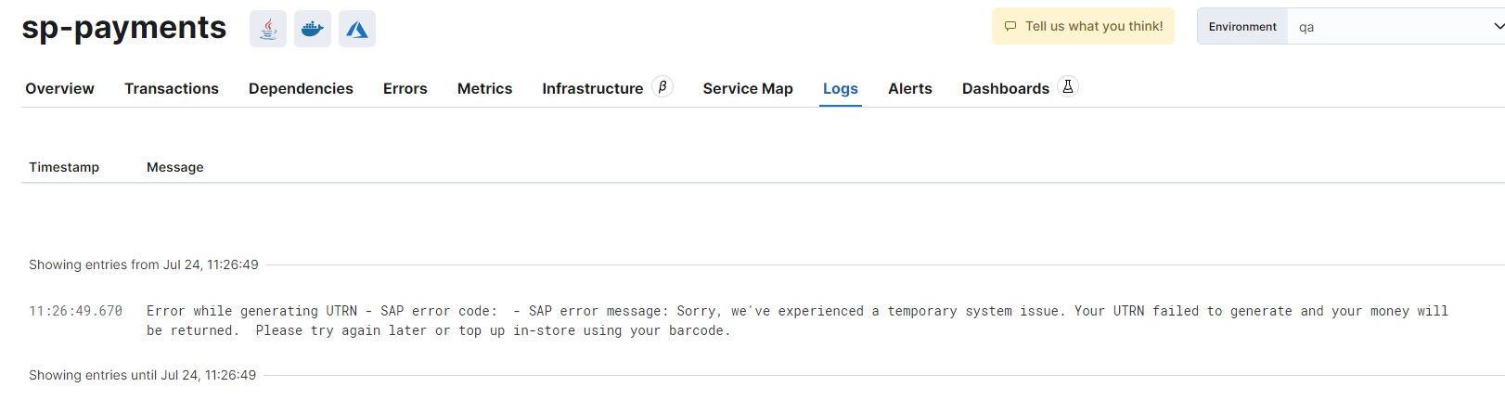

Log shows same error as app, contacted for help and got told below message therefore testing was successful as pre-existing error was found and brought to attention again.